Name - **Abhay Singh Patel**

Roll Number -**12040020**

**PART - 1**

**1)** The number of get-requests sent when the IIT BHILAI main page was browsed is **28**. The tool used is **Wireshark** (The whole Spreadsheet of get-requests [Found](https://drive.google.com/drive/folders/1FIxqB1Ui3bq8BXb8CWDj5SjhZaBcH-Ea) can be and the pcap file for the same can be [Found here](https://drive.google.com/drive/folders/1FIxqB1Ui3bq8BXb8CWDj5SjhZaBcH-Ea))

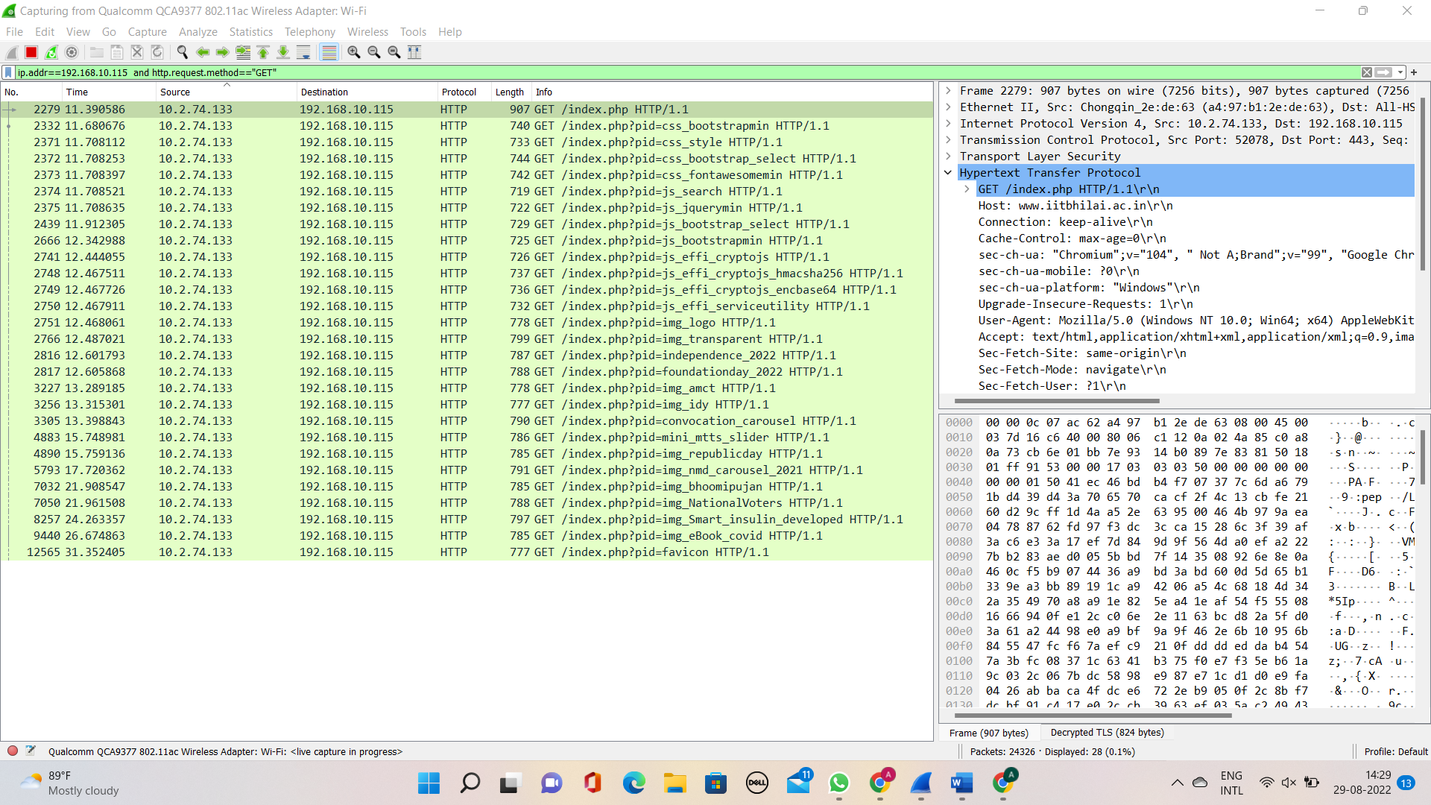

*Screenshot of the Wireshark window after the main website of IIT BHILAI is completely loaded with of getting request.*

The text requests can be obtained directly by using the command in Filter in

WireShark.

http.request.method == GET and http.accept[0:4] == "text”

Out of 28 get-requests:-

* Requests for embedded content: 10 (PNG, GIF, VIDEO file)
* text requests are total: 5

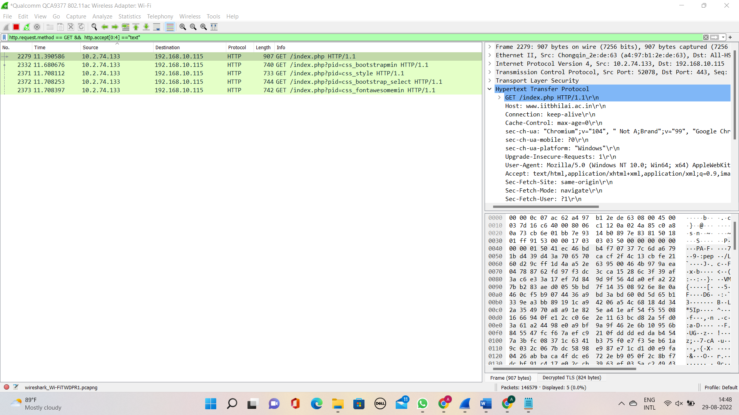

*Screenshot of the Wireshark window for the request for text*

IO graph for :

* Packets received to IIT BHILAI (website)

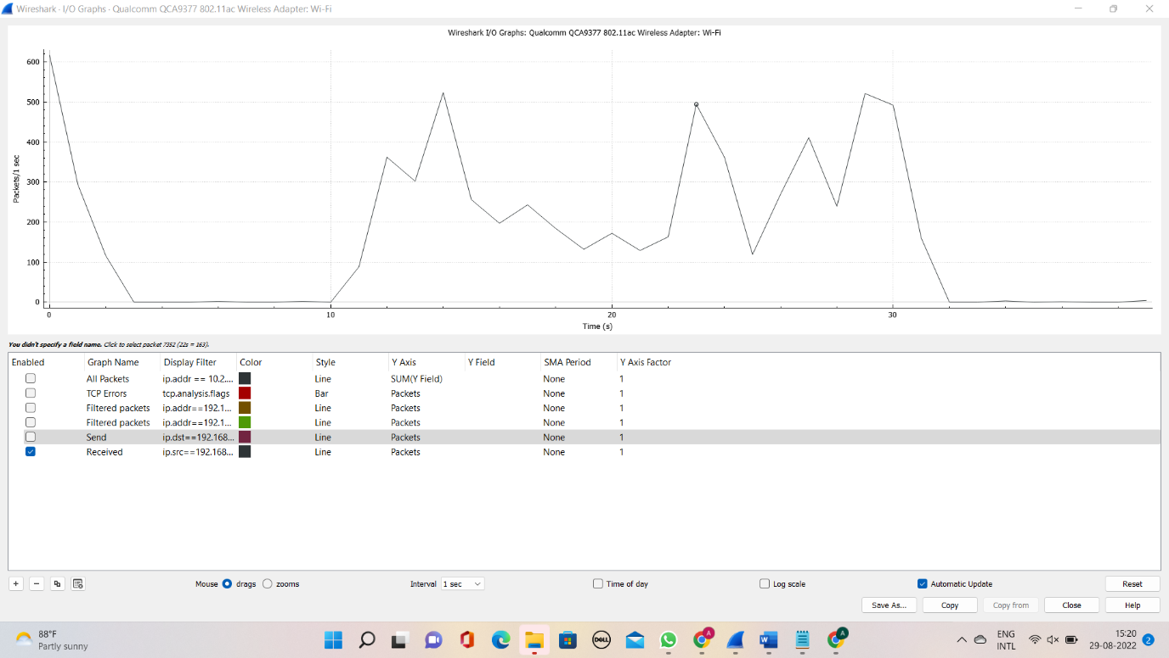

*Screenshot of the Wireshark window for I/O graph Received.*

* Packets send from IIT BHILAI (website)

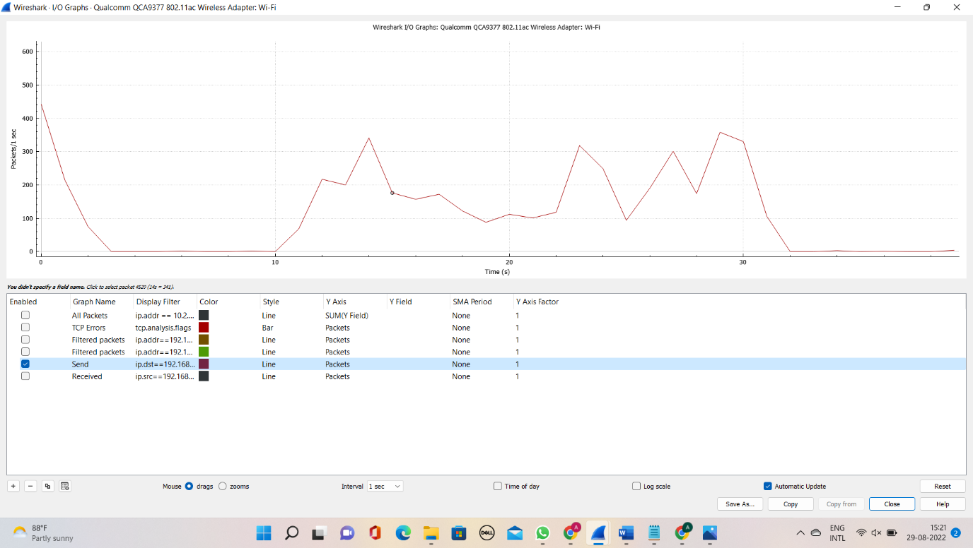

*Screenshot of the Wireshark window for I/O graph Send.*

* Packets GET from IIT BHILAI I/O graph. (GET)
* 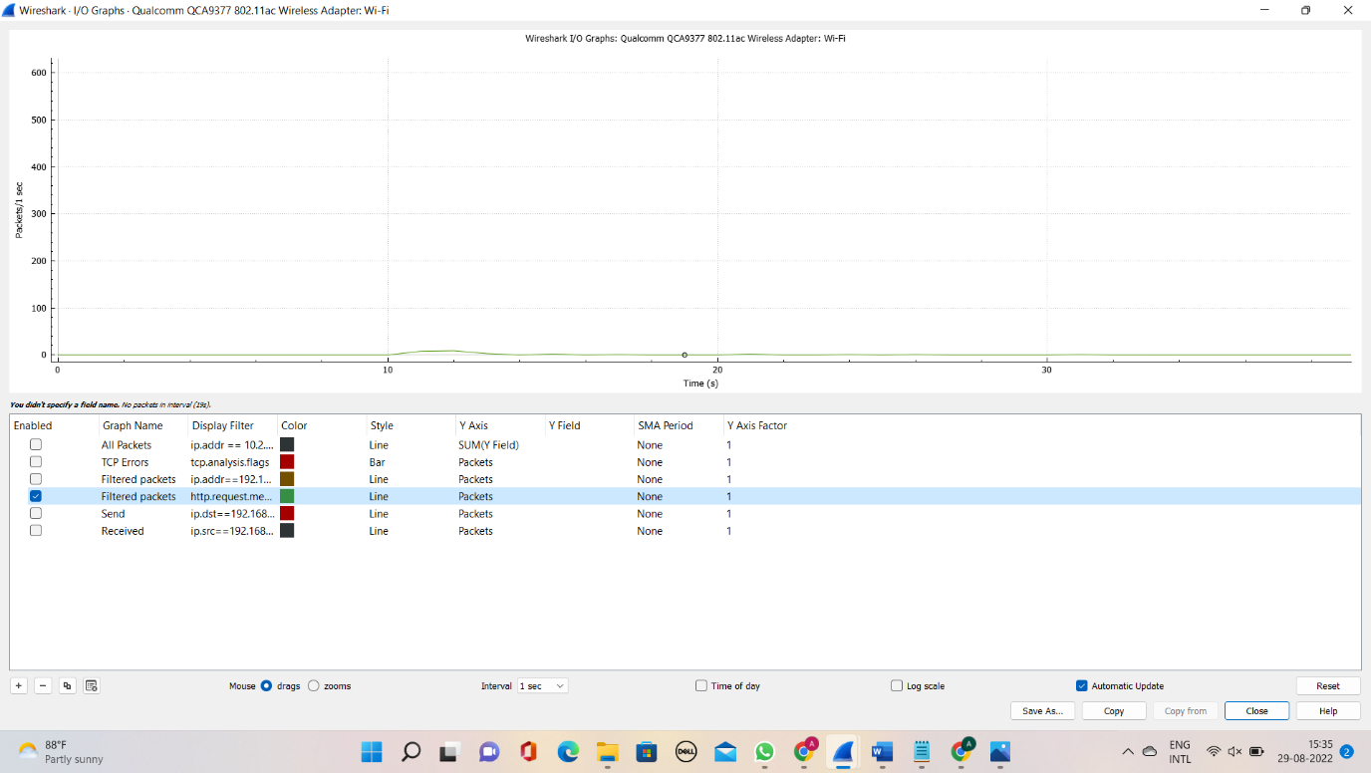

**2)**

**Total data length Data frame on the request page and response page are given below. There is a total of 21 response ports but I, have shown only 7** [**StackOverFlow**](https://stackoverflow.com/questions/20223992/how-to-find-the-number-of-content-of-bytes-returned-to-browser-by-the-server)

|  |  |  |  |
| --- | --- | --- | --- |
| **Request Frame** | **Response frame** | **File Data** | **Network frame response** |
| **207** | **251** | **31454 bytes** | **907 bytes** |
| **265** | **446** | **121033 bytes** | **740 bytes** |
| **268** | **445** | **12041 bytes** | **733 bytes** |
| **269** | **409** | **6065 bytes** | **744 bytes** |
| **270** | **405** | **31004 bytes** | **742 bytes** |
| **271** | **285** | **379 bytes** | **719 bytes** |
| **272** | **386** | **116840 bytes** | **722 bytes** |

**3)**

Image formed from Hex dump code from IIT Bhilai website using inbuild feature of Wireshark

Steps taken

* Firstly check 200 ok status frame
* checked 200 ok status only of those which has png file
* Then from Hypertext transfer protocol take file data
* Select show packet bytes then image formed.

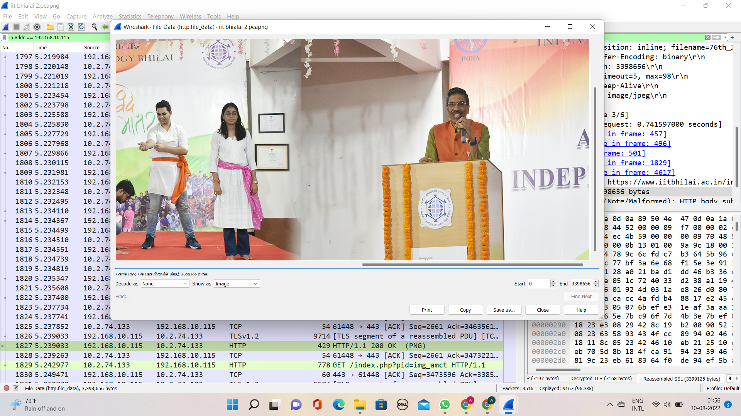

*Screenshot of the Wireshark window for a png file.*

This is the Hex code for this image you can convert this by using [**Codepen**](https://codepen.io/abdhass/full/jdRNdj)and inserting this file[**Dump Hex code**](https://drive.google.com/drive/folders/1FIxqB1Ui3bq8BXb8CWDj5SjhZaBcH-Ea?usp=sharing)

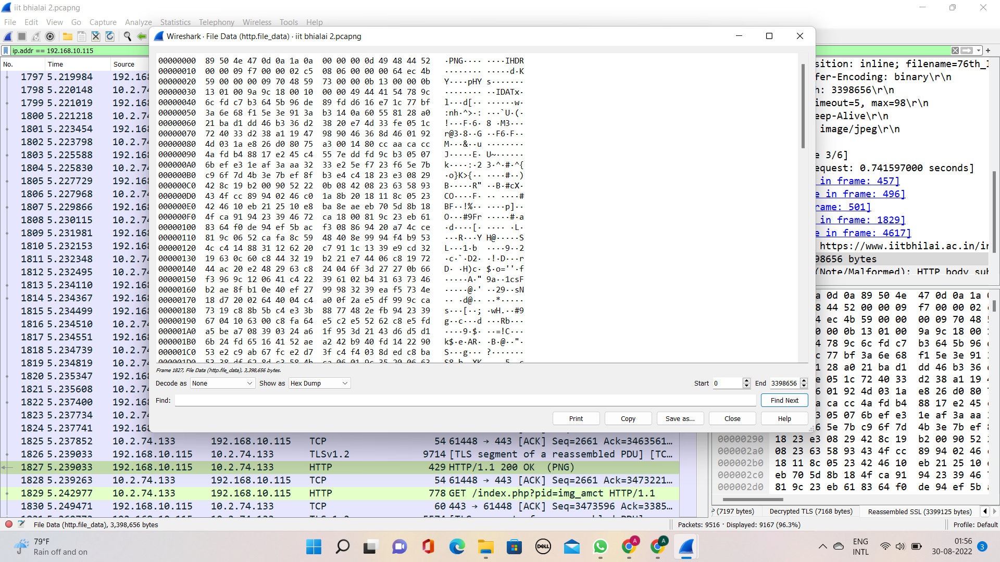

*Screenshot of the Wireshark window for hex code.*

**4)**

The Total amount of data sent and received between source and destination, is 282k bytes.

stepwise:

* Check the conversation from statistics in the menu bar
* In that select IP4 and check bytes transferred between destination and source(A→B)

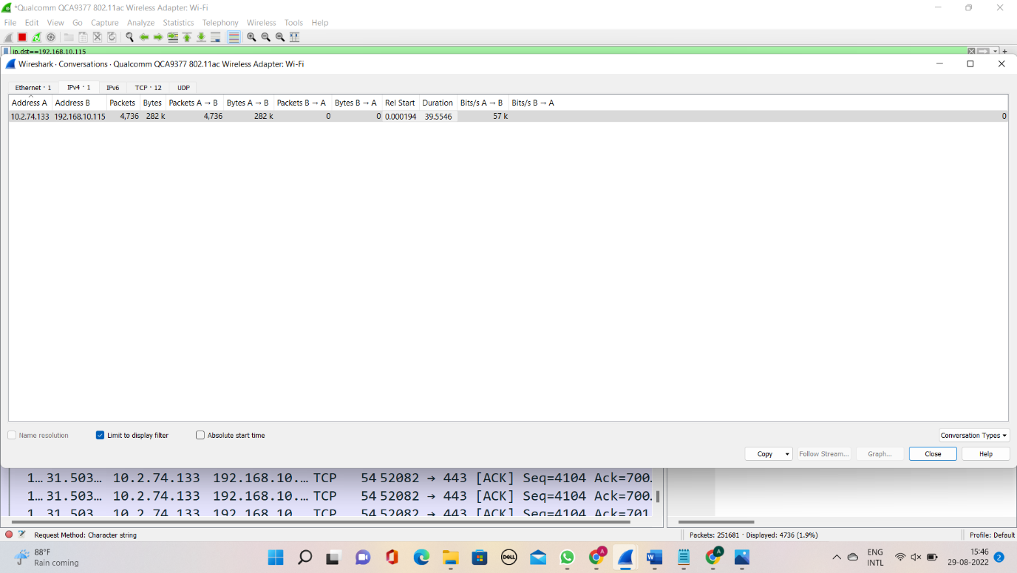

*Screenshot of the Wireshark window for total data transfer between src and destination.*

**5)**

1. No, I haven’t found any “IF-MODIFED-SINCE” line in the first HTTP GET request, but on another website, it’s showing. So, I think it may be a bug in the IIT Bhilai website.
2. Yes, the server did that explicitly because it return the contents in the line-based text data field.

As shown below I have open HTML code.

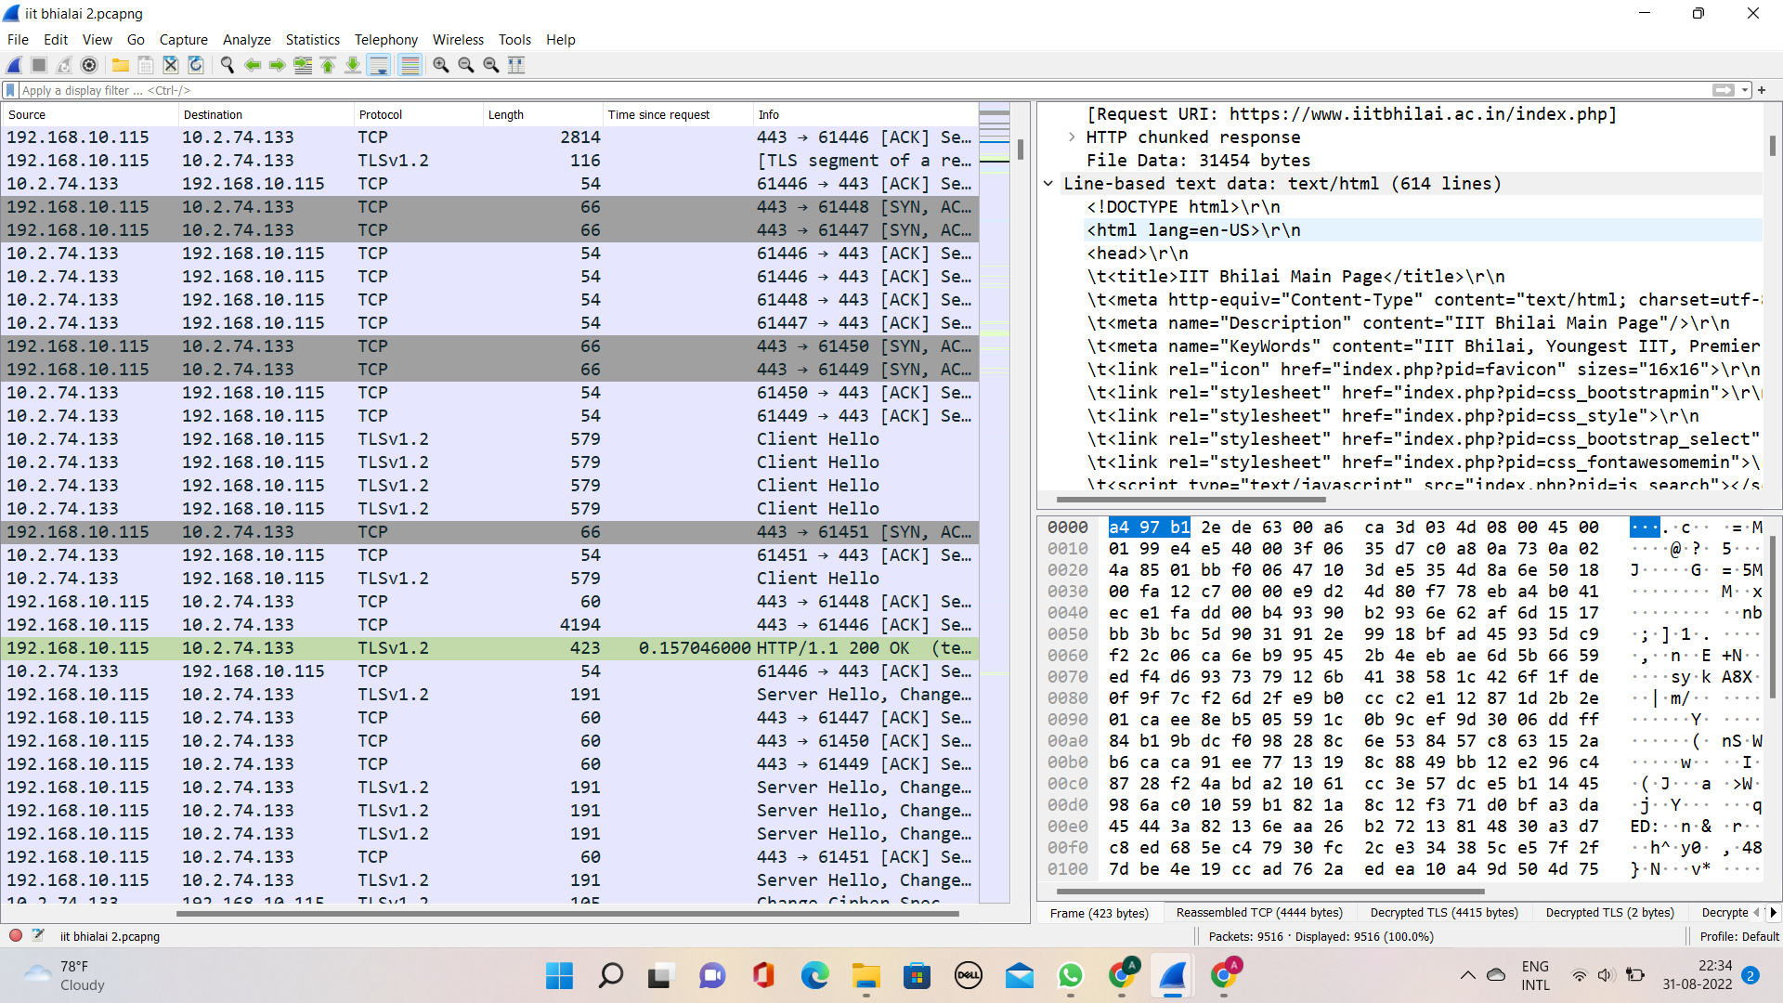

1. Yes, i have found code == 200(ok) status.

The only date I found is this Mon, 29 Aug 2022 10:30:43, therefore the last modified date was this.

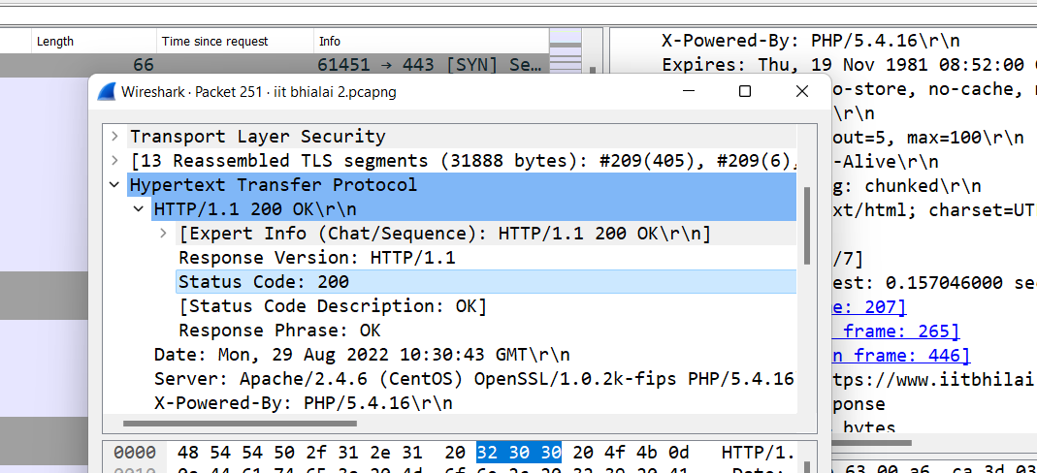

1. The HTTP 200 OK response meaning is that the request made by the client has been successful, but the meaning of the success depends on the four types of requests made by the clients. [Gfg](https://www.geeksforgeeks.org/http-status-codes-successful-responses/)

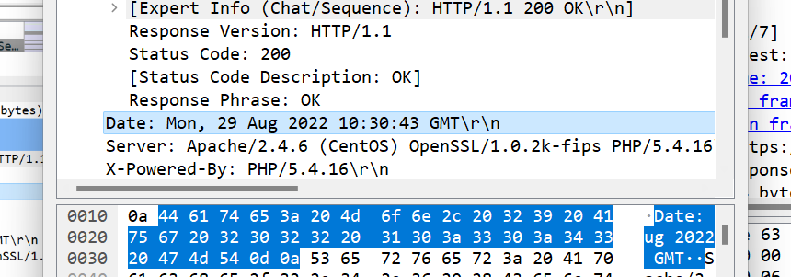

**6)** In this i have opened only iit bhilai which shows **16M** avgbit/s

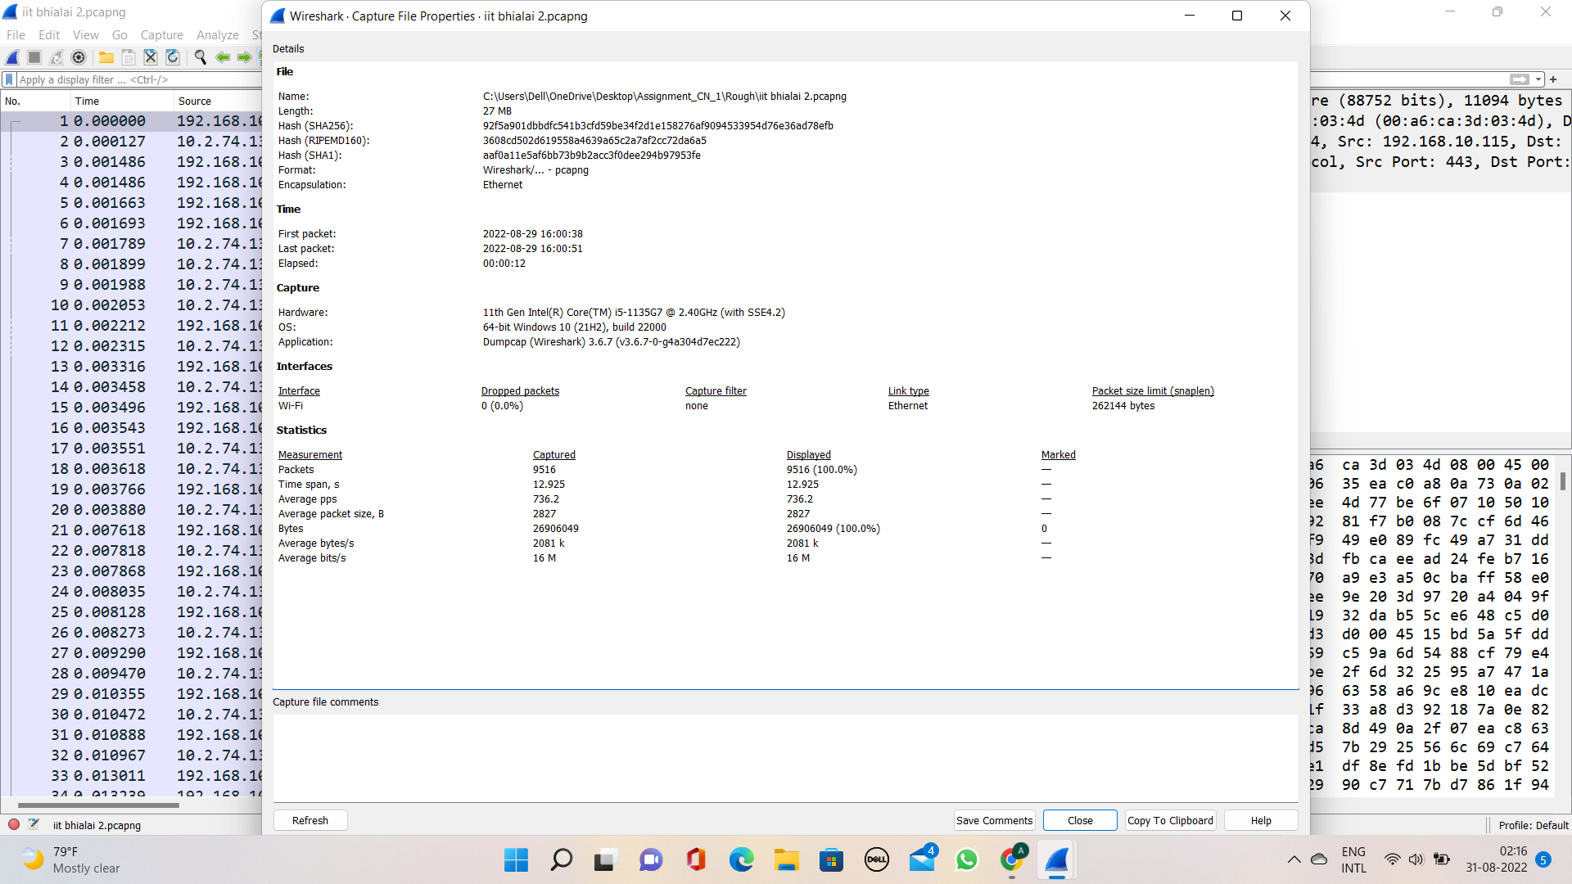

After that I opened codeforces website which has high traffic because of the ongoing contest, therefore the bytes/s decreased to 375k bits/s on IIT Bhilai from 16M/s.

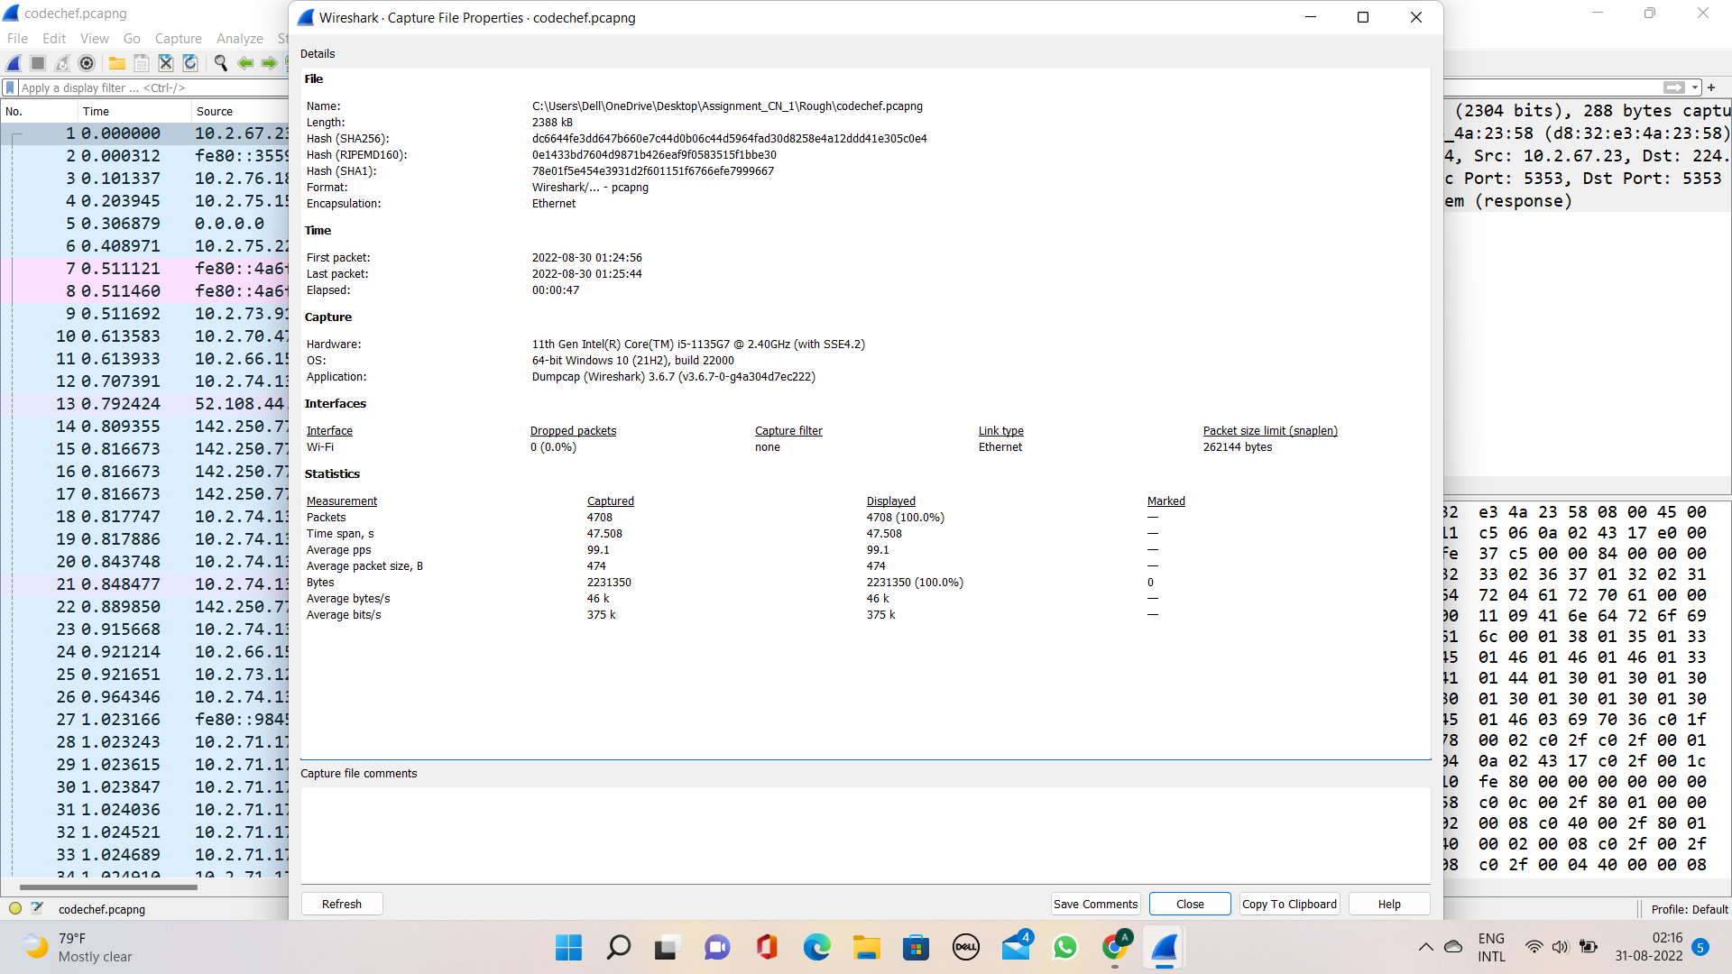

**7)** Total of 42 DNS packets have you observed in total

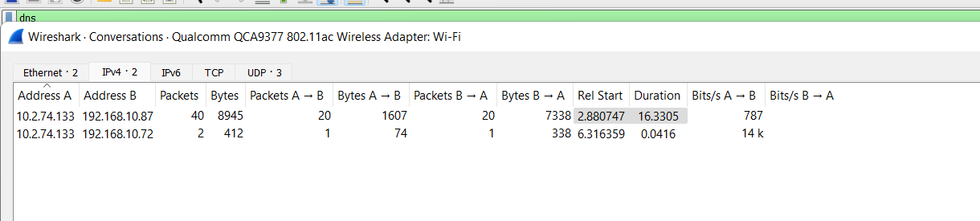

|  |  |
| --- | --- |
| **Domain name** | **IP address** |
| sb.l.google.com | 172.217.167.142 |
| cse.google.com | 142.250.182.46 |
| www.google.com | 142.250.193.132 |
| edge.microsoft.com | 204.79.197.239 |

b) Yes, we found as shown above.

**Part 2**

**1)**

The website used is: [www.codechef.com](https://www.codechef.com/users/pikachu25)

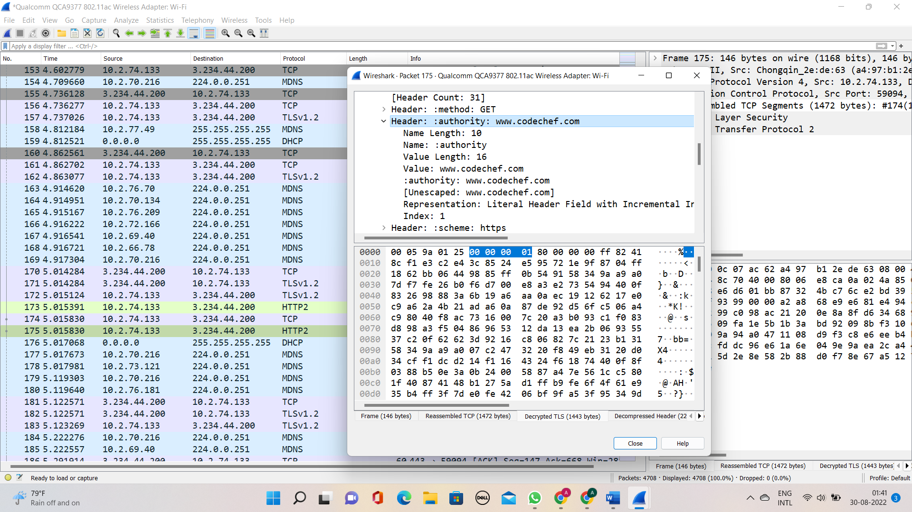

After searching <https://www.codechef.com/users/pikachu25> this to the browser, the Wireshark captured the packets. As shown above.

Step-wise decompose:-

* Firstly the domain([www.codechef.com](http://www.codechef.com)) is converted into an IP address (10.2.74.200) from the DNS server.
* After that, TCP handshake between my browser and CodeChef at frame No. 203

As shown below

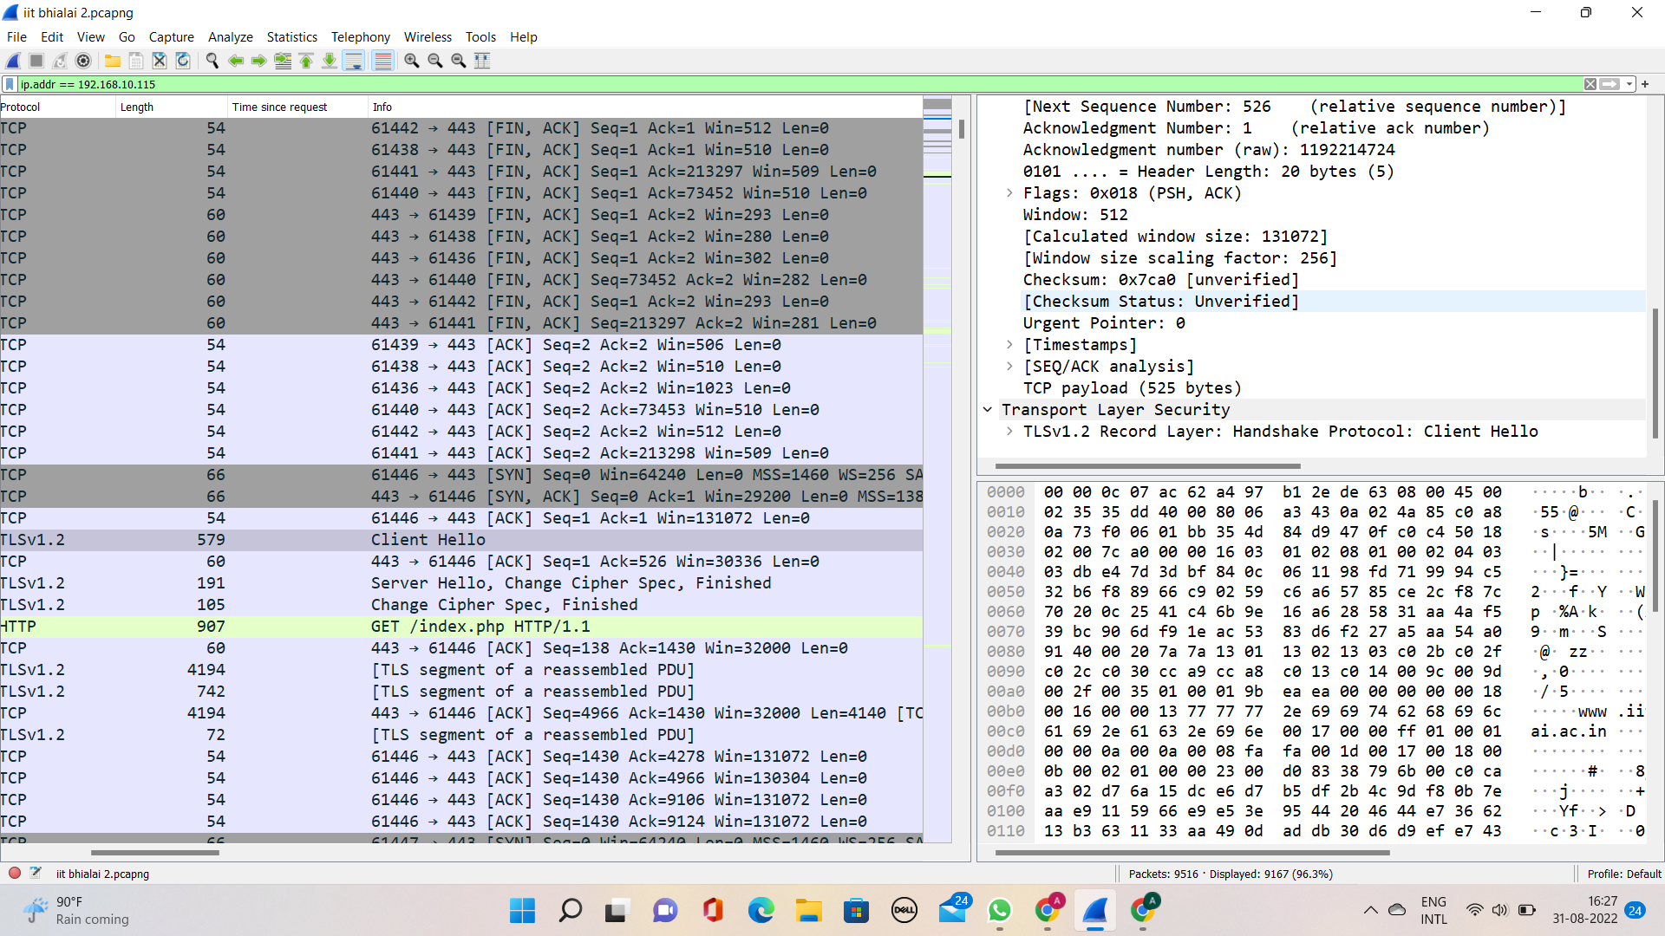

Then, I send the GET request (opening of CodeChef website), done by alive TCP connection frame number - 382 and received the endpoint in frame 413.

which was the opening of html,css, and js code of practice problems in CodeChef

It took a total of **0.260536000 sec** to load completely. (for that I have added a column through **(http.time)** through the edit section in the menu bar)

It takes a total of 6 packates(object) to load the page

A total of **9 TCP connections** are build between website and

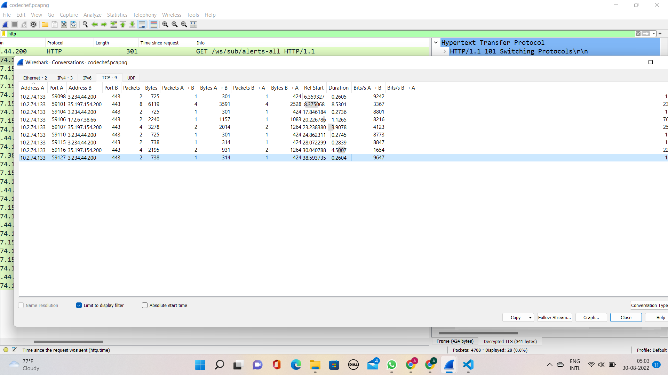

The packets that are transferred from codechef to my browser are through connections **1,4,1,1,2,1,1,2,1** correspondingly.

These are **persistent as you can see in the screenshot above that more than one object is fetched(more then one object is transferred in one transfer) in a single TCP connection.**

**And also, it’s showing HTTP /1.1\r\n means TCP keep-alive**

**TCP connection alive is build as shown below**

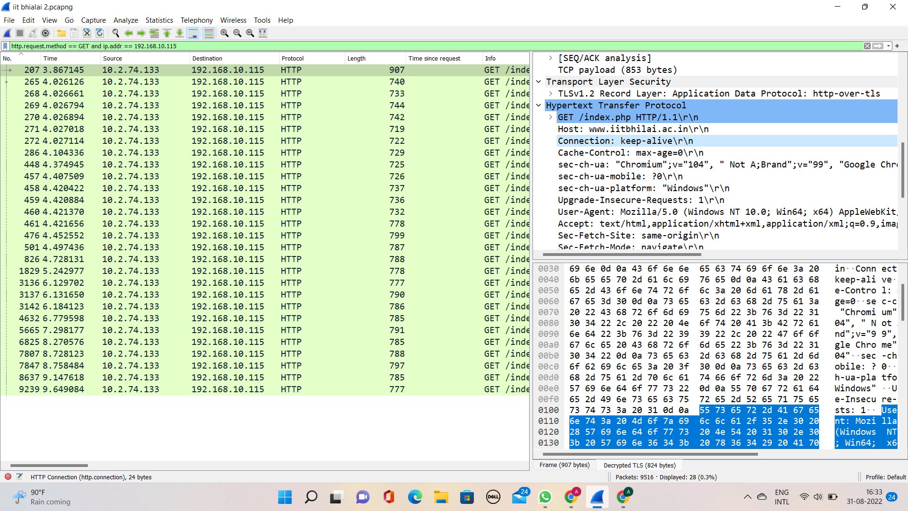

Seeing the “TIME SINCE REQUEST” column added, which shows the longest time taken was **1.126496000 sec** which was loading the solution file of other CodeChef users of practice questions.

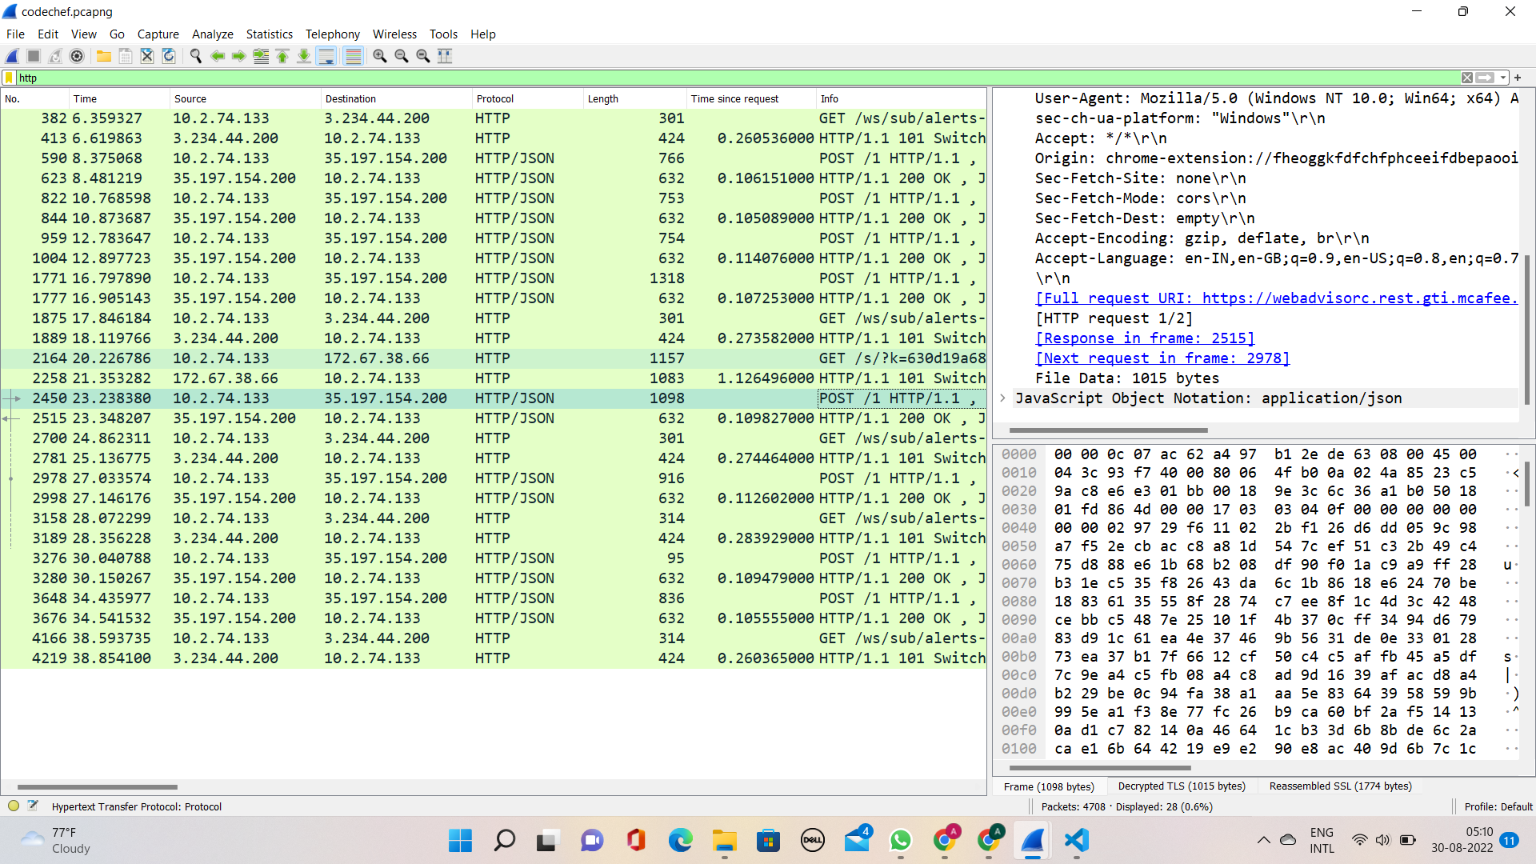

**2)** The dig (domain information groper) command is a flexible tool for interrogating DNS name servers. It performs DNS lookups and displays the answers that are returned from the queried name server(s).[DIG docs](https://www.ibm.com/docs/en/aix/7.1?topic=d-dig-command)

The process of knowing the root servers of IIT BHILAI web page using DIG is as follows:

As asked about the root servers without recursion. So, we use +norecurse command with dig command in **Ubuntu.**

* First let us list all the DNS name servers running. So, we run dig command without any URL. Result as shown below:-

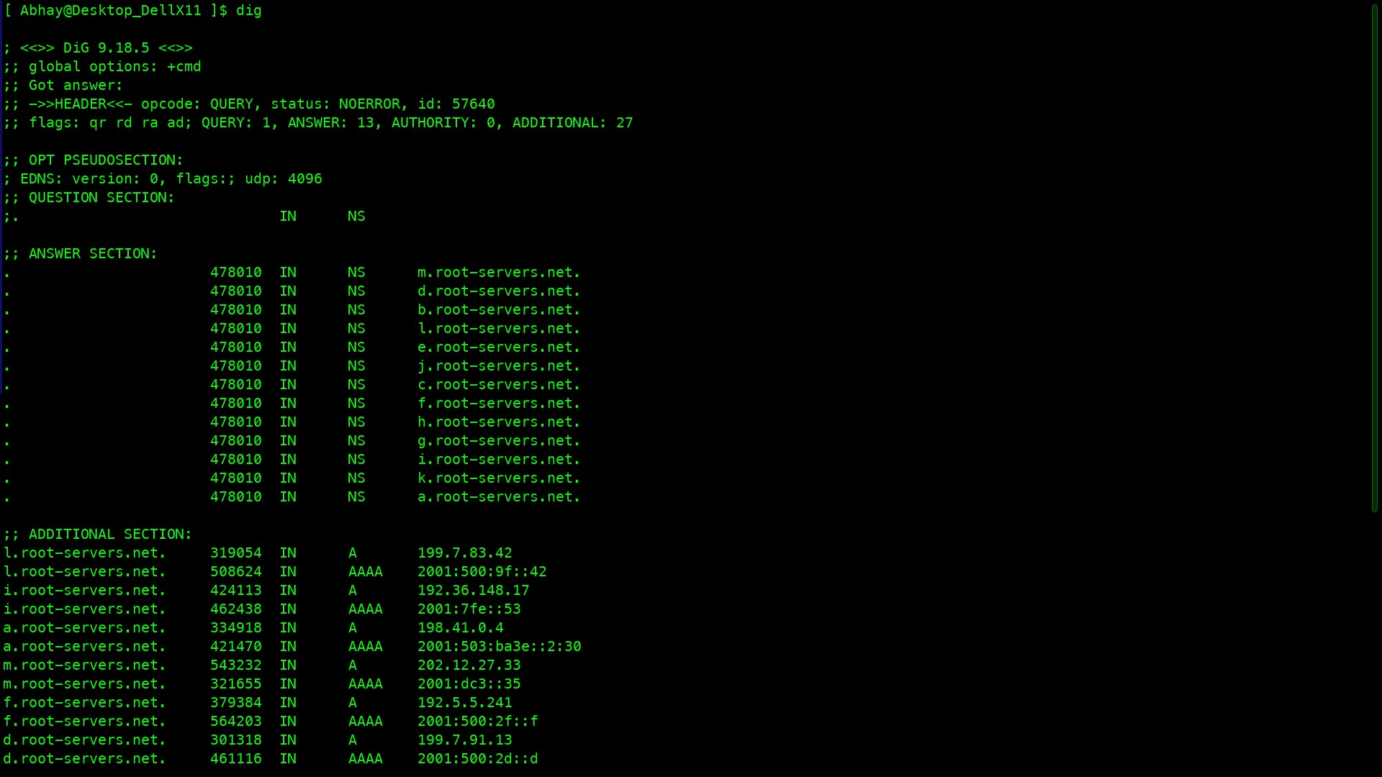

* Now, we have to gather DNS information of [iitbhilai](https://www.iitbhilai.ac.in/)
* To gather information we run a command —>

**$ dig @a.root-servers.net +norecurse www.iitbhilai.ac.in**

The result obtained from the above command lists several name servers like **ns1.registry.in** for the root server **.in** (refer to the screenshot below)

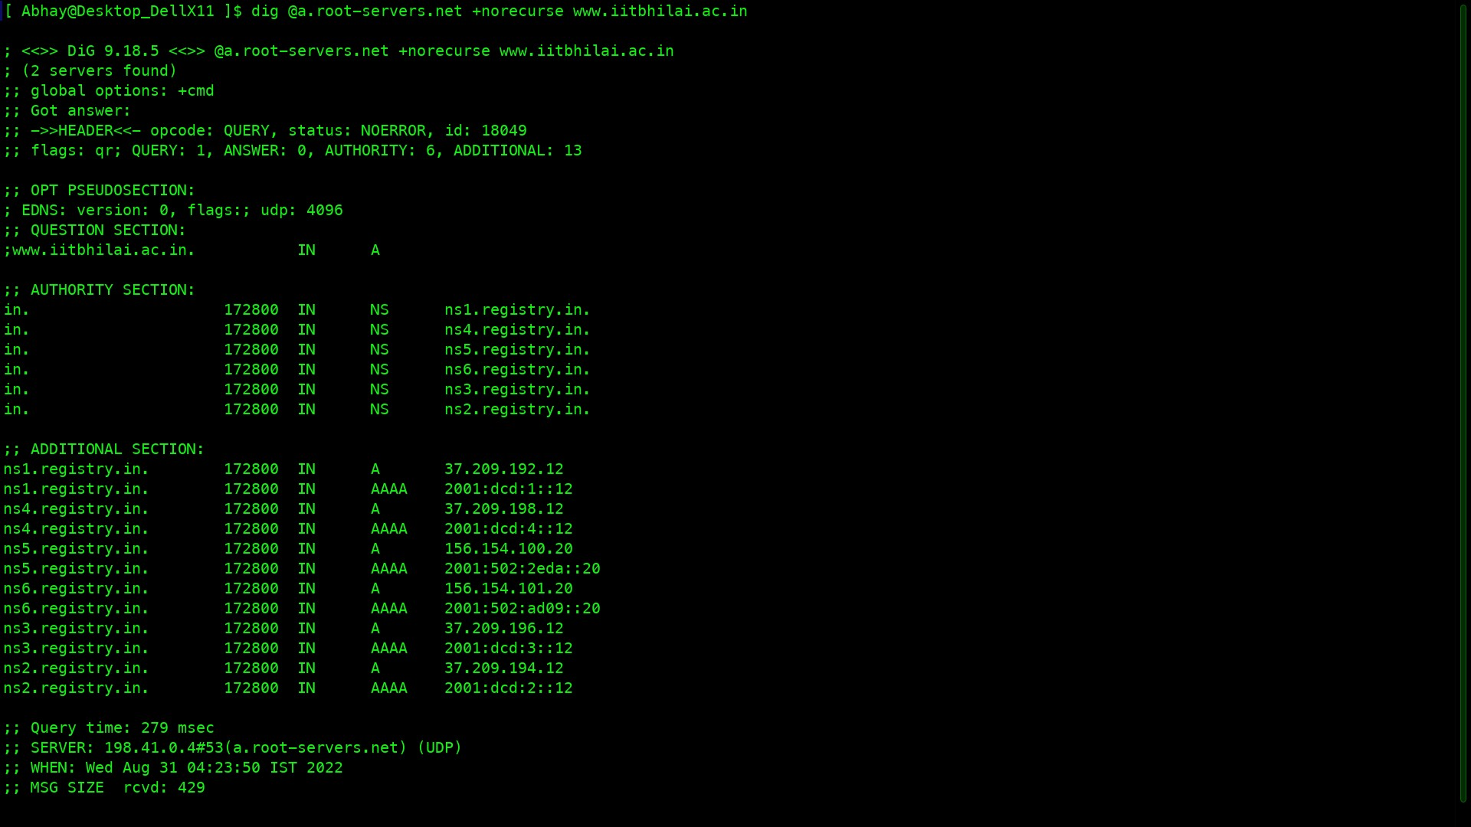

* We obtain the name servers in the additional section by the command used **$ dig @ns2.registry.in +norecurse** [**IIT BHILAI**](https://www.iitbhilai.ac.in/)
* After this,we obtain two name servers shown below in the screenshot which is used in the next step.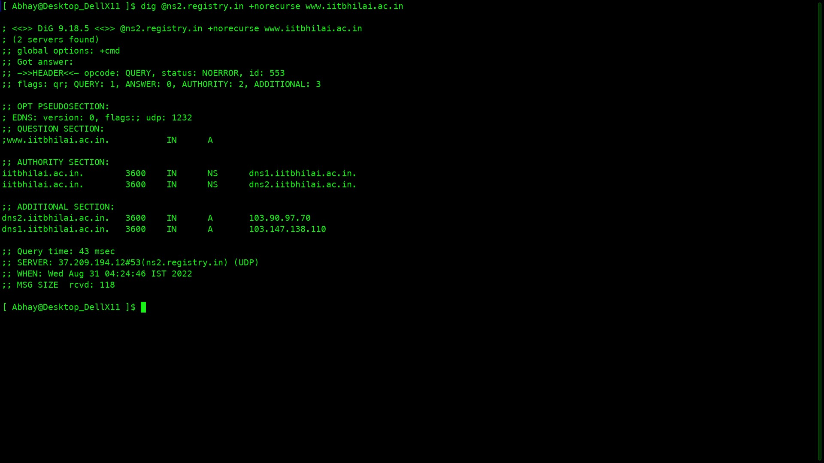
* Now the next level of hierarchy, through command **$ dig @dns1.iitbhilai.ac.in +norecurse www.iitbhilai.ac.in**

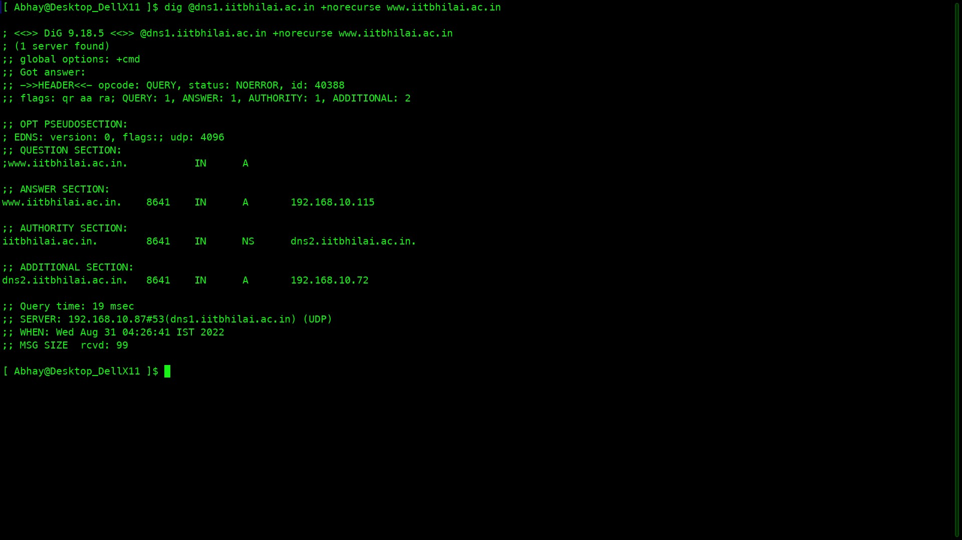

* Now, we obtain only one server in the additional section and we also get an ANSWER section which means we have obtained the address of IIT BHILAI which is **dns1.iitbhilai.ac.in** and the IP address of [www.iitbhilai.ac.in](http://www.iitbhilai.ac.in) is found as 192.168.10.115
* Every Server per page

a.root-servers.net

ns2.registry.in

dns1.iitbhilai.ac.in

**NOW REPEATING SAME STEP FOR CODECHEF WEBSITE(.com)**

1. Opening [Codechef](https://www.codechef.com/)

* we use one of the DNS server’s URL running on my machine to gather information about the server of

**$ dig @a.root-servers.net -norecurse** [**www.codechef.com**](http://www.codechef.com)

shown below.

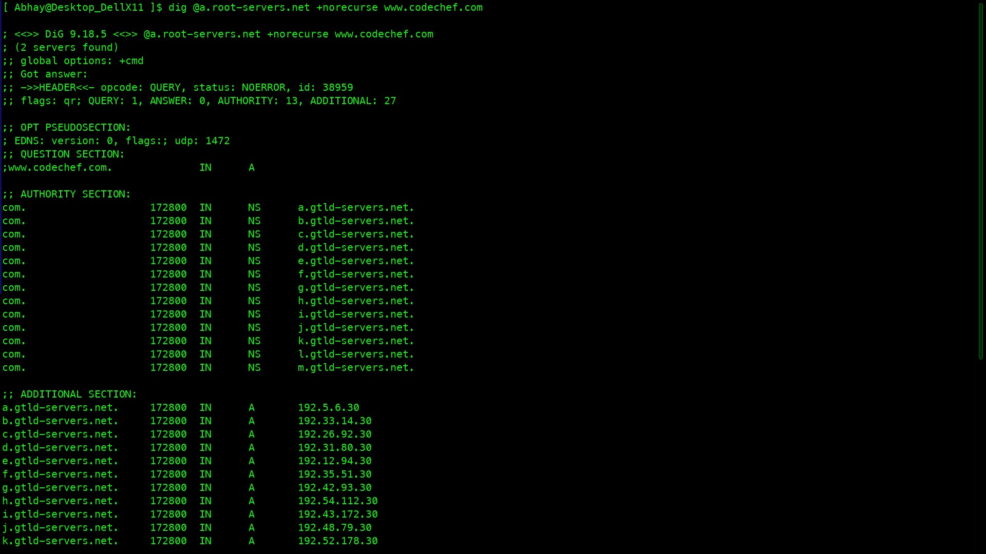

* We obtain the name servers in the authority section by the command used

**$ dig @a.gtld-servers.net +norecurse www.codechef.com**

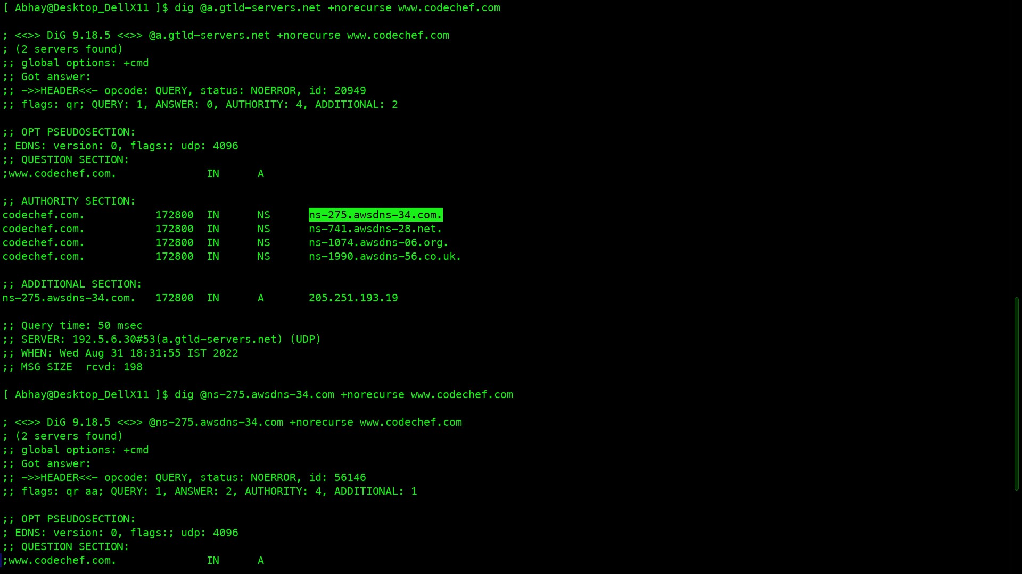

* Now the next level of hierarchy, through command

**$ dig ns-275.awsdns-34.com +norecurse www.codechef.com**

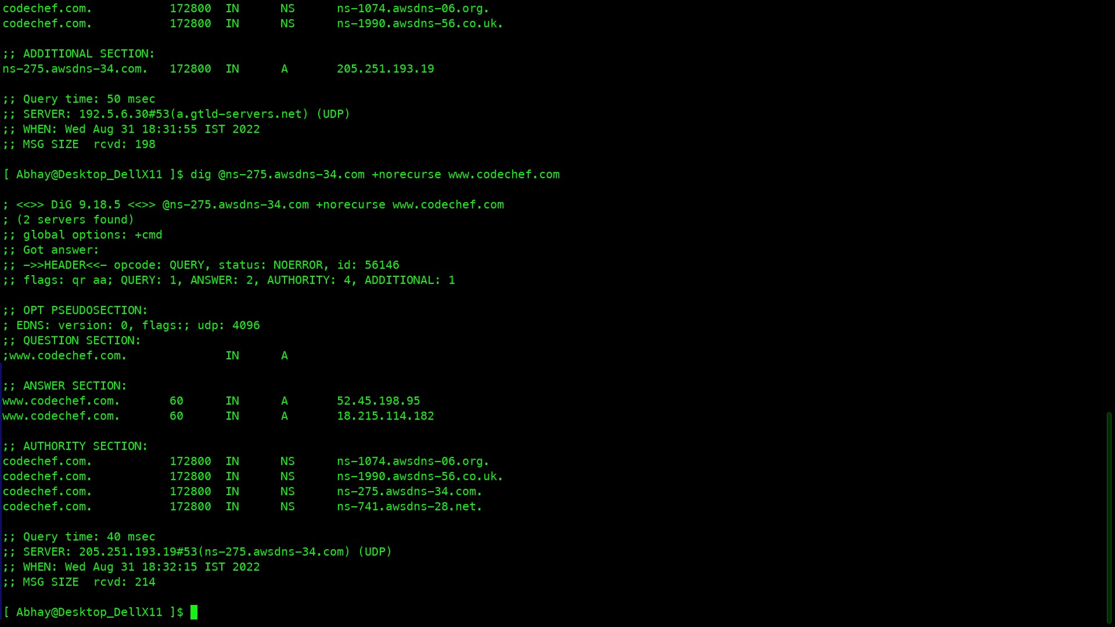

* Finally, the required server address for the webpage [Codechef](https://www.codechef.com/)

[www.codechef.com](http://www.codechef.com) (18,215.124.95)

[www.codechef.com](http://www.codechef.com) (52.45.198.95)

* Intermediate Name-serves
  + a.root-servers.net
  + a.gtld-servers.net
  + ns-275.awsdns-34.com

**Same for Edu website IITKGP.**

* Firstly DNS server’s URL running on my machine to gather information about the server of iitkgp.ac.in

dig @a.root-servers.net +norecurse www.iitkgp.ac.in

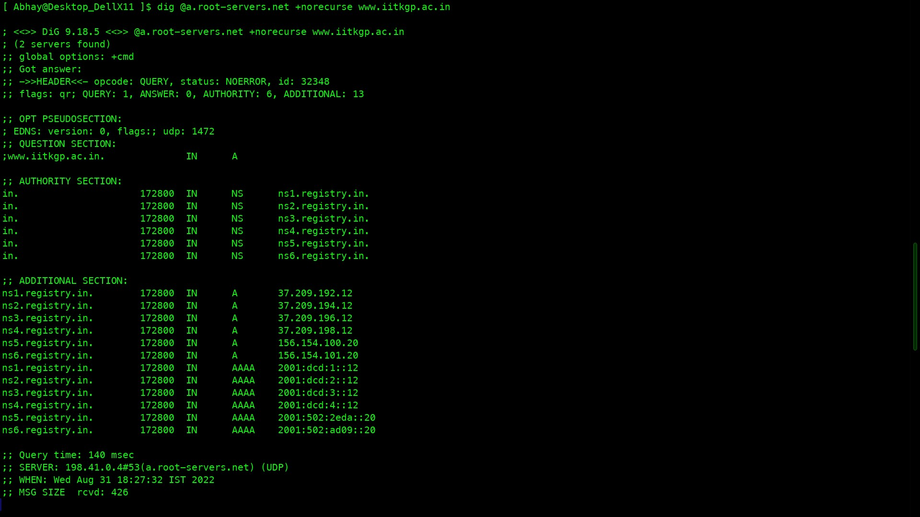

$ dig @ns1.registry.in +norecurse www.iitkgp.ac.in

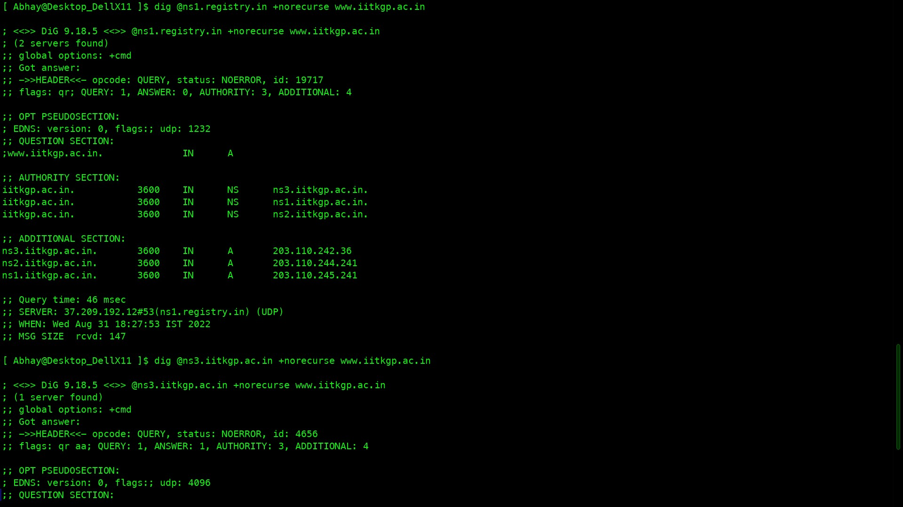

$ dig @ns3.iitkgp.ac.in +norecurse www.iitkgp.ac.in

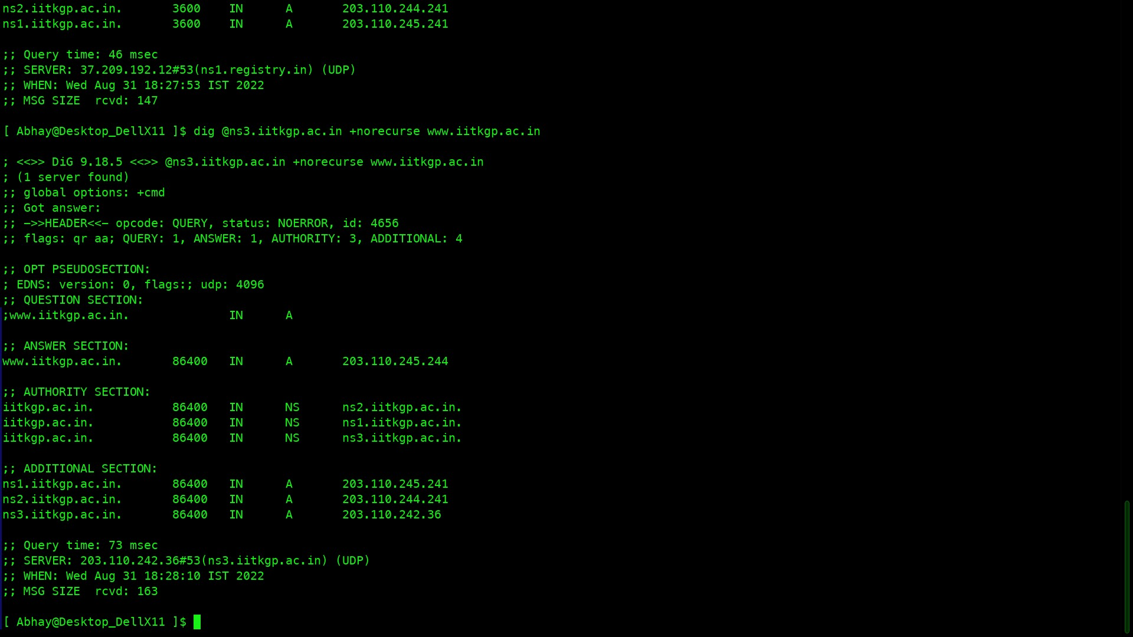

We obtain 3 server in additional section and get anser section which means we have obtained the address of iitkgp is 203.110.245.244

Name- servers

a.root-servers.net

ns1.registry.in

ns3.iitkgp.ac.in

**3)** To check all the active TCP ports in system,I run the following command in **Command Prompt**

**$netstat -anob**

* This command gives all the active servers running in my PC
* Total number of active TCP are **107**
* Total number of active UDP are **89**

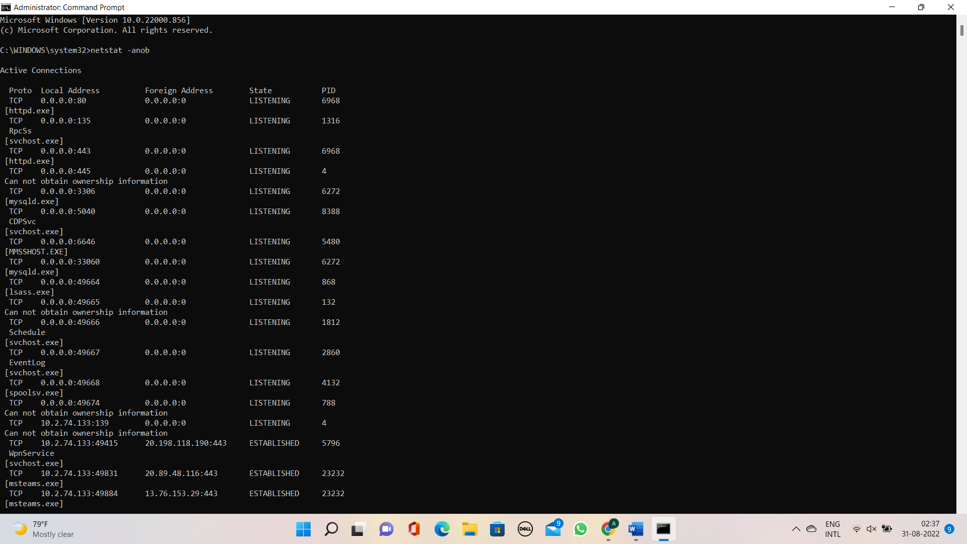

* Port of web chrome is 49889 and PID is 23232
* As we cannot identify the PID of specific TAB running in my chrome browser.
* we get the PORT number and PID of the operation running on the system along with name of the system running.

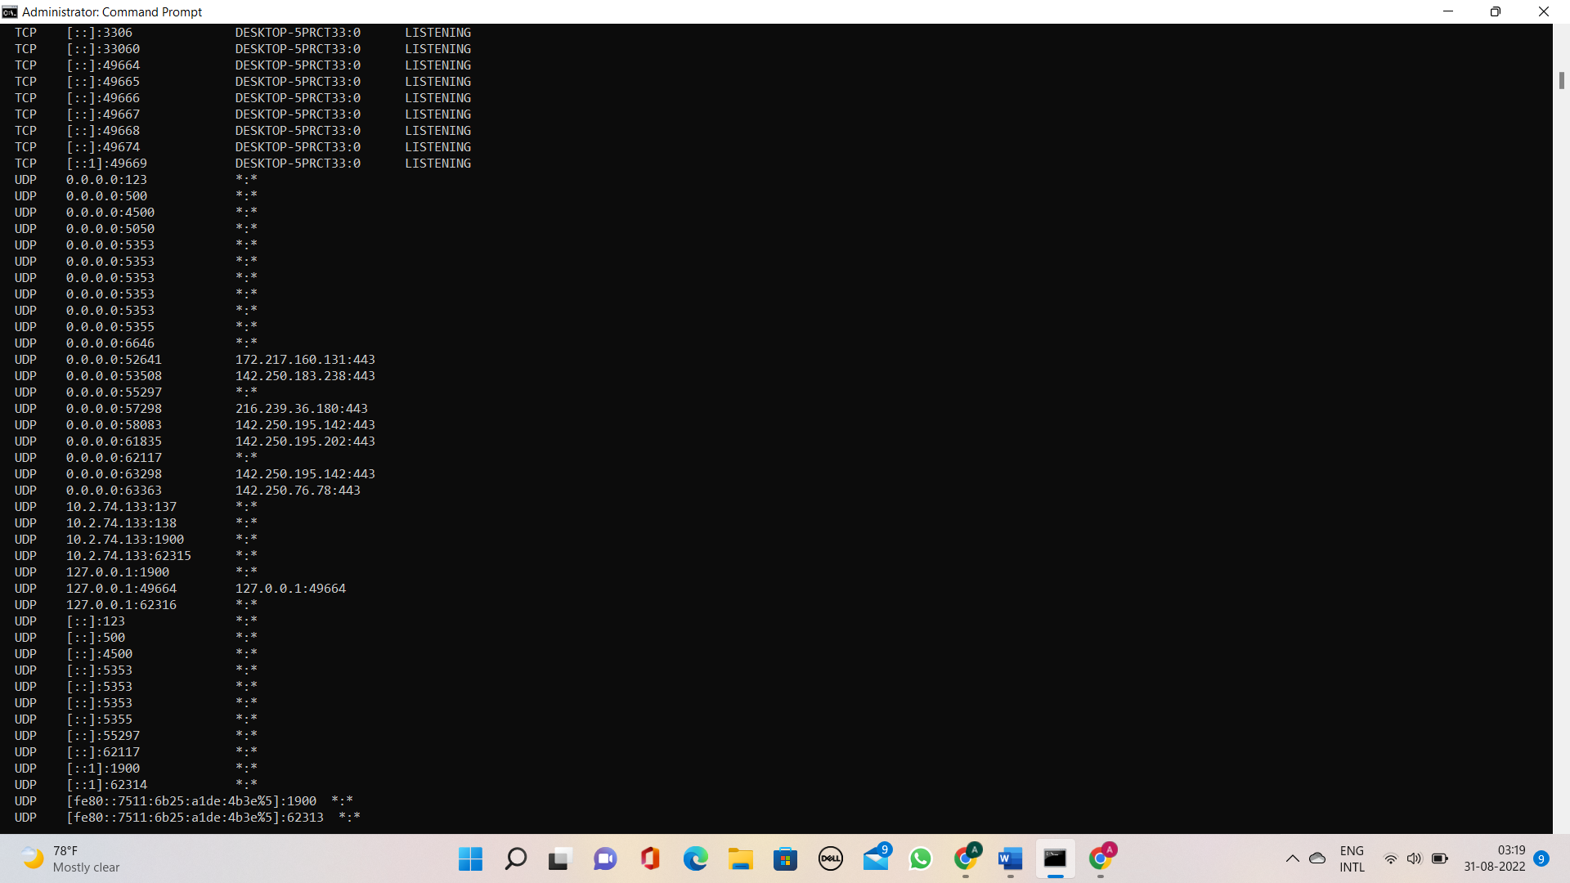

* The standard ports are:-

|  |  |
| --- | --- |
| **Protocol** | **Standard Port** |
| HTTP | 80(LISTENING) |
| DHCP | 67(NOT ABLE TO FIND) |
| DNS | 53(NOT ABLE TO FIND) |
| SMTP | 25((NOT ABLE TO FIND)) |
| FTP | 20 or 21(NOT ABLE TO FIND) |